**State of the art in Idea Management Systems and Idea Life Cycle**

**Subproyecto**: SP6. HOTEL DEL FUTURO EN INTERNET

**Paquete de trabajo**: PT6.2 Tecnologías de Información para caracterización

**Tarea**: T6.2.1 Gestión de ideas de cliente

**Control de versiones**

Registro de modificaciones

|  |  |  |  |
| --- | --- | --- | --- |
| **Versión** | **Fecha** | **Autor** | **Referencia a las modificaciones** |
| V0.1 | 15/05/2012 | Adam Westerski | Creación del documento |
|  |  |  |  |
|  |  |  |  |
|  |  |  |  |

Distribución

|  |  |  |
| --- | --- | --- |
| **Versión** | **Fecha** | **Destino del documento** |
| V1.0 |  | Intranet Proyecto THOFU |
|  |  |  |

**Indice**

1 Introduction 4

2 Brief History of Idea Management 4

3 Idea Life Cycle 5

4 Dependencies between idea life cycle stages 12

5 Conclusions 13

6 References 14

# Introduction

The concept of innovation in organizations has become an important issue along with the increasing competitiveness of markets. Many companies realised that it is crucial to constantly develop their value proposition and innovate not only to attract new clients but also to avoid losing current ones. On the other hand, reports indicate that the global financial crisis in 2007 had an impact on the innovation process within enterprises. The harsh economic conditions indeed sometimes lead to reducing investments (Kanerva & Hollanders, 2009) but more interestingly change the motivation for innovation. Apart from increasing competitiveness or customer satisfaction, companies seek to use innovation as a tool to reduce production costs (Andrew et al., 2009*a*). This can lead to a conclusion that even in the post crisis times the question is no longer why but how to innovate successfully.

One of the answers to this question is: with the help of communities gathered around and inside the enterprise. In this paper, we investigate the concept of community powered innovation and in particular focus on a sub-domain of innovation management called idea management. The contemporary systems in this area are typically implemented with web based technologies and are used to collect ideas from a particular community to select the best concepts for implementation and deployment. In addition, one of the important rising roles of Idea Management Systems is to connect the so called fuzzy front-end of innovation with other enterprise processes to efficiently manage innovation.

Most of the initiatives to improve or extend idea management software are undertaken by the industry while in academia the concept has not been discussed much. Therefore, the aim of this paper is to provide an introduction to the topic and in addition propose a formal categorization of techniques that occur during the idea management process. The rest of the article is organized as follows. First, to bring better understanding of the topic, we summarise the past efforts in the domain and give appliance examples based on commercial case studies (see Sec. 2). Next, in Section 3, we present the 'idea life cycle' - a set of consequent stages in the idea management process driven by interactions of different actors and communities with the system and the changes in data. Building on top of that framework, we propose how the quality of the entire process can be improved through gathering feedback on each stage of the life cycle (see Sec. 4). Finally, the main conclusions of the article are drawn out in Section 5.

# Brief History of Idea Management

Innovation management practices are not new and have been introduced in various organizations much before the burst of IT systems (e.g. Toyota has a history of over 30 years of innovation management oriented towards the capture of ideas (Baumgartner, 2004)). However, the term 'idea management', as used today in relation to the IT market, has been created in reference to systems that emerged in the late 90ies (Rozwell et al., 2002). Those platforms aim to aid all aforementioned practices of idea management and allow organizations track community generated ideas as they progress through enterprise procedures. The goals and scope of those tools has been continuously evolving ever since their origins.

Historically, the precursors of Idea Management Systems were simple suggestion boxes maintained as part of internal corporate systems or with the advent of Internet - company homepage. However, this approach did not introduce any software facilities that would actually aid the management of captured community ideas. These suggestion boxes were just an additional input mechanism. The progress came with connecting the technology with dedicated back-end facilities. The abilities to store, display and organize the submitted ideas gave birth to Idea Management Systems. One of the drawbacks at the time, that limited the software capabilities, was simple user input structure. This has changed along with the huge popularity burst of the Internet and the rise of the so called social web. The Idea Management Systems have taken advantage of the Web 2.0 techniques to extend the original submission boxes as idea capture methods. As a consequence, richer and better organized user input data brought new opportunities to develop management backends towards better data presentation and selection.

While the initial period of Idea Management Systems evolution was about harnessing basic technologies and setting directions, the contemporary systems focus on defining a formalized software-aided idea management process that is well defined, traceable and most importantly repeatable. On top of that, in search of new methodologies, some additional practices are proposed to extend the existing phases towards other areas of innovation management, e.g. the idea generation towards creativity studies (implemented in Ingenuity Bank (IBank, 2009)) or idea assessment and status monitoring towards market studies and strategic planning (e.g. in Accept Ideas (AcceptIdeas, 2009)).

# Idea Life Cycle

An Idea Management System is a software aided approach to manage innovation on its **stages of evolution**:

* Idea Generation
* Idea Improvement
* Idea Selection
* Idea Implementation
* Idea Deployment

**Idea Generation** is about reaching out to the community or a particular group of people and ***extracting the ideas*** from them.

**Idea Improvement** is about enabling people to ***collaborate with each other to improve the ideas gathered***.

**Idea Selection** aims to harness the high volume of data submitted by the crowds and ***choose the best ideas***.

**Idea Implementation** starts at a point when an idea gets a positive review and is accepted to be put into production. The goal of this stage is to ***transform ideas into products or services***.

**Idea Deployment** is the process that ***tracks the successfulness of ideas*** after they have been delivered to the target audience as products.

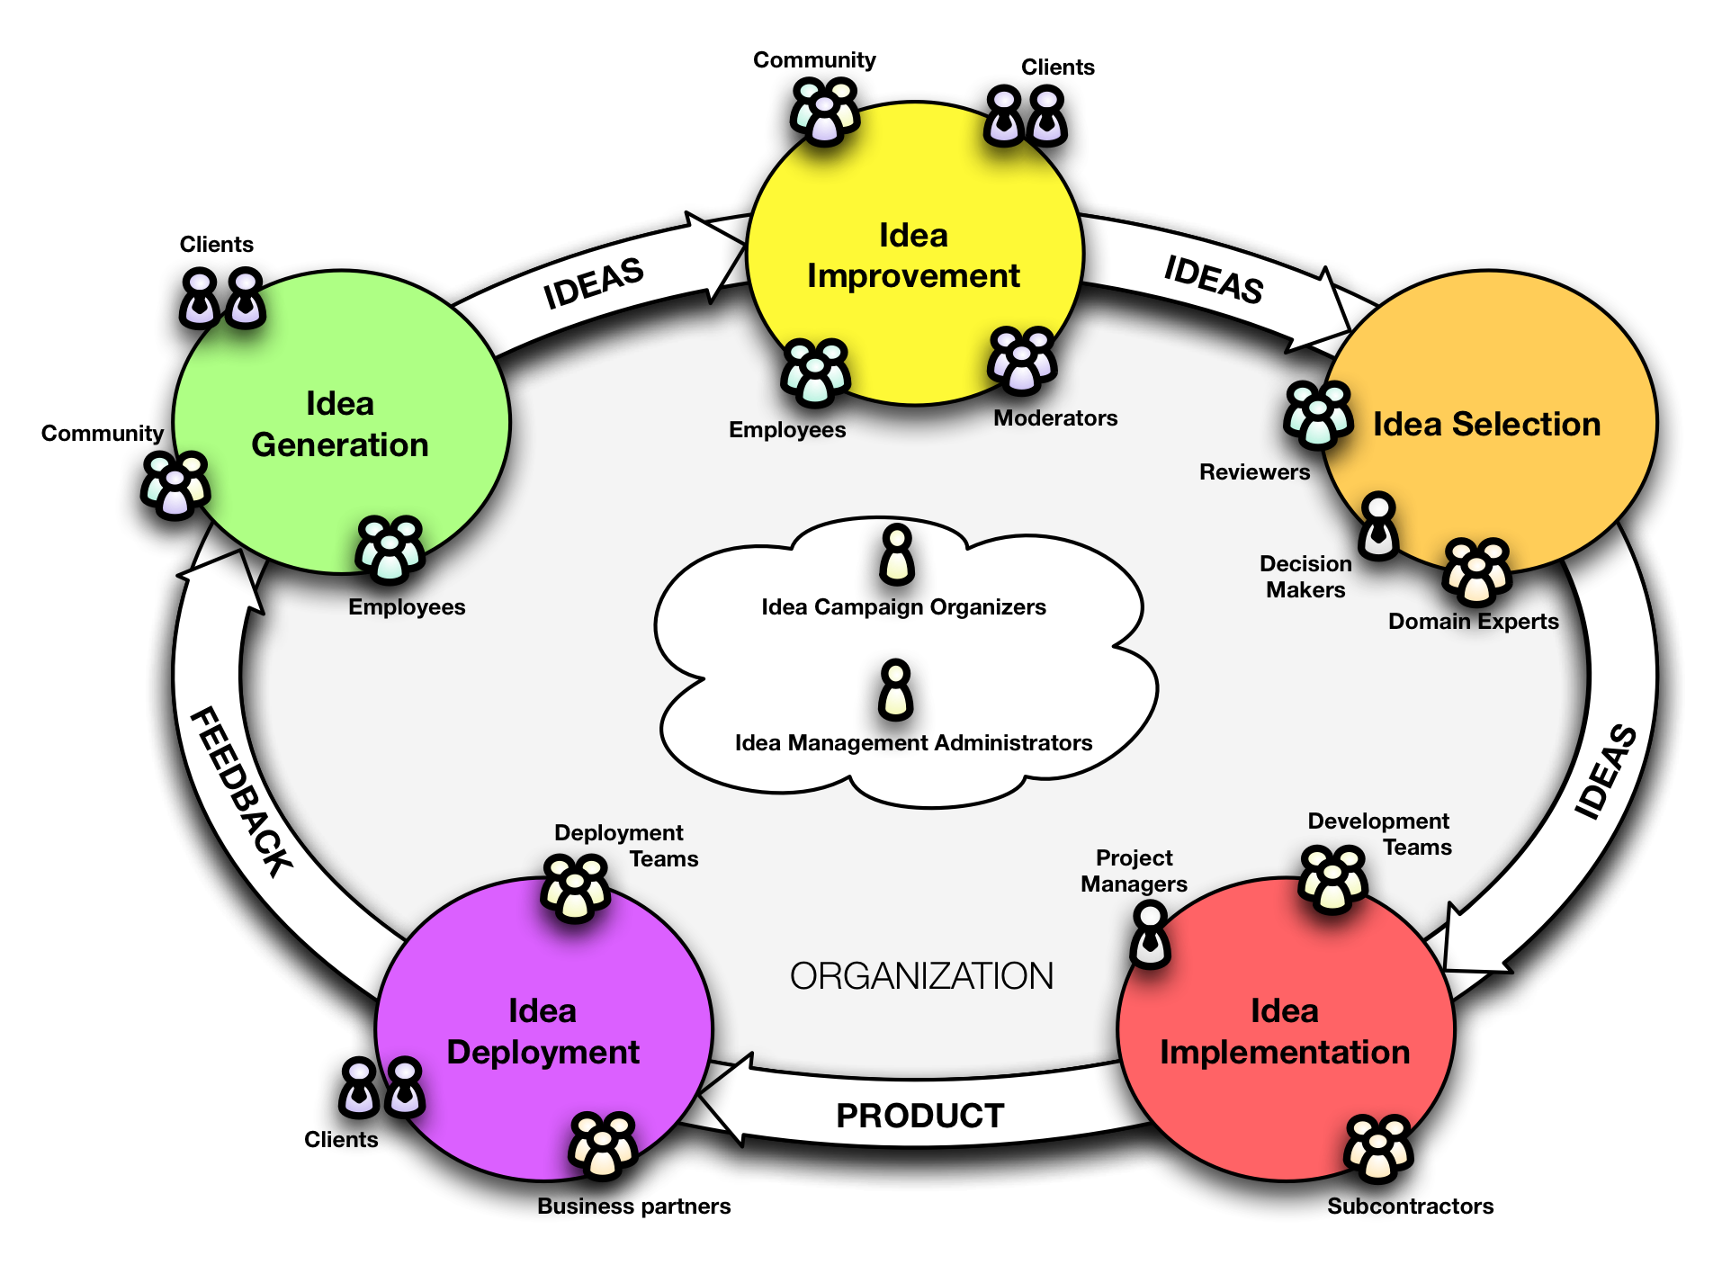

**Figure 1.** Idea life cycle and communities.

Ideally, input and output of all of those stages should be closed in a cycle to reuse the data for improving the quality of future ideas and idea management procedures (see Sec. 4). Furthermore, each of the stages in this cycle can involve participation of many actors coming often from different communities, either inside the company or from an external environment (see Fig. 1). In the next subsections, we shall detail the techniques in each stage that push the data changes in ideas across the life cycle (see Fig. 2). We shall also highlight the practices and activities characteristic for each of the phases.

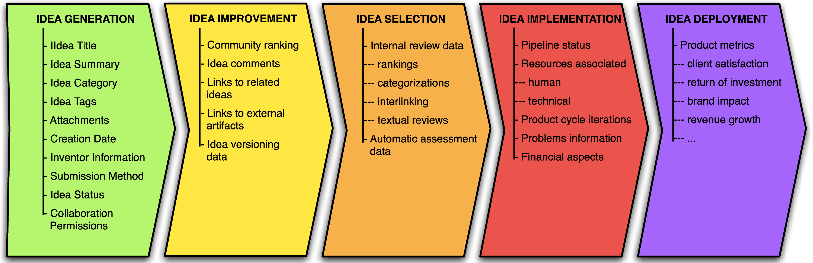

**Figure 2.** Idea life cycle data evolution.

*3.1 Idea Generation*

The input for this phase is gathered from the people that interact with a computer system or telecommunication infrastructure. The end product of this phase is a *semi-formalized idea*. This goal can be achieved in a number of ways depending on the idea capture method:

* push methods (user is explicitly asked for ideas on a given topic)
* pull methods (user ideas are extracted or inferred from some content)

Among the push methods the most popular solution is simple *web input form* (e.g. used in products of Salesforce (Salesforce, 2009), BrightIdea (WebStorm, 2009) and most of other on the market) where user fills out the data corresponding to the idea formalization such as: title, summary etc. However, some other possibilities are: *a guided process* (e.g. indirect questions that lead to formalization of idea in Ingenuity Bank (IBank, 2009)) or *dedicated services* connected to external input devices (e.g. mobile phone (IBank, 2009)). Additionally, systems based on the push methods can be constructed to support either a single user idea generation process or a collaborative idea generation process (e.g. through brainstorming (IBank, 2009; Idearium, 2009)).

On the other hand, the pull methods are about extracting ideas either from textual content (e.g. social media) or based on verbal contacts with the client. The key element of this method is that information analysed is not submitted by the user with intention of idea generation. The techniques used, aim to separate ideas from unrelated opinions and unwanted content. Among those techniques, we can distinguish: *data mining* (Cabena et al., 1997) in conjunction *opinion mining* (Liu, 2008) for textual content located outside organization systems or integration with other systems and implementing data ﬂows for content within the organizations systems e.g. Customer Relationship Management integration (e.g. implemented by Salesforce (Salesforce, 2009)).

Apart of deciding upon the usage of either push and pull input techniques the item that especially matters at the idea generation stage is encouraging the inventors to actually approach the system and contribute their ideas or opinions and secondly to ensure the good quality of the content. The support for such activities is being quite often built into Idea Management Systems as part of the preparation process for idea generation competitions (e.g. as a reward system for best innovators).

Finally, the outcome of all the aforementioned practices of this phase is an interlinked set of data that can be broken down into following:

* Idea Title
* Idea Summary
* Idea Category (assignment to some fixed predefined categories)
* Idea Tags (categorization with custom keywords) *−* Attachments (rich media like pictures, videos etc.)
* Creation Date
* Inventor Information (idea is interlinked with user profile)
* Submission Method (optional depending on system capabilities)
* Idea Status (indicates the position of idea in the company internal process pipeline)
* Collaboration Permissions (some default preset depending on the system and selected scenario for idea collaboration)

*3.2 Idea Improvement*

Once the ideas are submitted it is a good practice to immediately share them with public and see what other participants of the idea competition think. This way, before ideas are assessed by dedicated staff from the organization, data is incubated in the community for a period of time, improved and confronted with mass opinion. Idea Improvement is about community interaction and collaboration. Therefore, this stage includes:

* all the post processing of ideas done by the community after the original content is submitted
* the moderation practices needed to organize that content and support the community

The post processing techniques can be directed towards modification of existing idea content or extending it. In case of modifications the same input techniques as used during the idea generation are valid, however in addition it is needed to set the rules for modifications and track changes. The modification policies require inclusion of profiling, authentication and privilege lists inside the Idea Management System. Once this is available a direct extension is traceability of changes which can be resolved though *idea versioning* (e.g. in Accept Ideas (AcceptIdeas, 2009)) handled similar to Source Code Management (SCM) such as SVN (Subversion, 2009) or CVS (CVS, 2009). Sometimes both profiling and versioning challenges are resolved with existing technologies e.g. through implementing wiki-like input (AcceptIdeas, 2009).

The support for modifying ideas by community members is useful, however it requires a lot of dedication and effort from an individual. Therefore, the techniques that allow users to make small additions to extend ideas are equally important: discussion support, community ranking methods, and idea interlinking.

The discussions between idea competition participants are most often facilitated with the model taken directly from Web 2.0 social spaces such as forums, blogs etc. In practice, this is implemented as comments for ideas (e.g. in IdeaScale (IdeaScale, 2009)) but also sometimes extends to additional forums, dedicated blogs or even external popular community sites (such as Facebook or Twitter) integrated with the Idea Management System e.g. in Salesforce Ideas deployments from Dell (Dell, 2009) or Starbucks (StarbucksIdea, 2009)).

Idea comments and discussions are a natural way to improve ideas and express opinions, however this type of user input is not quantified and hard to analyse when it grows in size. Therefore, Idea Management Systems often introduce additional tools for quantified community based idea ranking:

* *simple up/down ranking* (often similar to Digg e.g. Salesforce Ideas (Salesforce, 2009))
* *buying and selling idea shares* (in systems that implement prediction market mechanisms (Spann & Skiera, 2003) e.g. Nesco Idea Exchange (Nesco, 2009) or IDEM (Bothos et al., 2008))
* *idea games* (idea competition participants compete according to a set of rules e.g. ref-Quest (Baalsrud Hauge et al., 2008) or Idealyst (Toubia, 2006))
* *hybrid ranking systems* (e.g. up/down ranking combined with a limited pool of votes that is refiled based on some rules, e.g. Newsfutures Idea Pageant (Newsfutures, 2009))

The above ranking methods are one of the attempts to move some of the problems of the idea assessment phase (see Sec. 3.3) into the community improvement stage. However, it is not the only technique practised for community supported assessment. In addition, quite often Idea Management Systems deliver simple support for idea interlinking. In most systems this is implemented as duplicate detection that results in a decrease of information volume during assessment phase. However, it could also be possible to extend this concept up to similarity comparison (e.g. feature similarity based on research done in opinion mining (Hu & Liu, 2004)), time-line dependencies (partially implemented in reference to idea requirements in Accept Ideas (AcceptIdeas, 2009)), or idea evolution dependencies (done in many systems in a simple form of idea status tracking).

Similarly as in the idea generation phase, all types of activities performed during the idea improvement phase result in additional data added to the idea description:

* Community ranking data
* Idea comments
* Links to related ideas
* Links to artifacts outside the Idea Management Systems (e.g. social collaborative portals, external implicitly user linked media etc.)
* Idea versioning data (full versioning information or partial e.g. modification date)

*3.3 Idea Selection*

The goal of the following stage is to select the best ideas and propose them for implementation. This can be achieved with data browsing and search techniques. However, the task is not straightforward and gets complex due to the characteristics of data from previous stages (Jouret, 2009; Turrell, 2008): high volume, big redundancy of data, and large amount of trivial ideas. The three most important techniques to cope with those problems are:

* idea assessment (reviews run periodically and in parallel to the selection process)
* machine aided data pre-processing (computational heavy tasks such as statistics, pattern detection etc.)
* filtering and clustering (textual and graphical methods applied during selection to enhance idea browsing and search)

The idea assessment done by internal organization reviewers is supposed to enrich the community created idea description with alignment to organization strategy, goals and current needs. To gather the input from reviewers similar tools as during the Idea Improvement stage can be used:

* ranking tools
* categorization
* interlinking
* textual reviews

In contrast to community assessment the reviews done internally can be much more complex and demanding, e.g. ranking can be split into many themed categories (e.g. in Accept Ideas (AcceptIdeas, 2009)). Furthermore, the assessment can be potentially customized through profiling of reviewers who can provide better assessment if it is aligned to their area of expertise e.g. market analysis, strategic planning, product cycle placement, financial analysis (e.g. cost vs. return of investment) etc.

The input given by reviewers during this stage and by community earlier can be processed with machine algorithms to extract additional value and calculate metrics. The algorithms can be oriented towards mining connections in structured data (Cabena et al., 1997) (e.g. measure average similarity ratio based on different categorizations or review metrics) or to extract valuable information from textual comments and reviews with natural language processing technologies (NLP) (e.g. measure opinion polarity for ideas with opinion mining technologies (Pang et al., 2002)). Furthermore, if the Idea Management System has a well developed personalization module then connections between users and submitted content can be tracked and reasoned upon (e.g. detecting patterns in community behaviour to measure individual users reputation and expertise).

In the end, both algorithm aided assessment and human assessment ultimately produce a number of characteristics of an idea. In the selection process all this data is utilized to deliver different view points for the person responsible to choose the final ideas (or best candidates) for implementation. The idea database is explored by defining criteria aligned with idea characteristics for idea filtering, ordering and search. The techniques can be either textual (tables and lists) or graphical (diagrams, charts, other innovative graphical presentation or navigation techniques).

On the idea selection stage ideas are enriched with the following data:

* internal review data
* automatic assessment data
* idea ranking and selection data

*3.4 Idea Implementation*

The idea implementation phase starts when selected ideas are approved for implementation. The goal is to transform ideas into products, services or perhaps just actions. At this stage, Idea Management Systems come very close to project management tools, product life cycle management etc. In those areas, quite often organizations already have dedicated and specialized systems that support management and development activities. Therefore, Idea Management Systems take a number of approaches ranging from complex to very limited:

* full embedded support for project management (allocation of resources, definition of tasks and requirements, reporting support etc.)
* integration with popular project management/ product life cycle tools (e.g. through open APIs)
* no development management aside of status reporting

Each of these approaches has been implemented in practice by companies that successfully deliver commercial idea management platforms. When implemented by the same vendor, the support for project management is either a module in the idea management platform (e.g. in Salesforce Ideas (Salesforce, 2009)) or a separate product with very tight integration (e.g. BrightIdea Pipeline (Pipeline, 2009)). On the other hand, the interfaces to popular project management software or open APIs limit the scope and complexity of idea management software to a more consistent range of tools (e.g. Accept (AcceptIdeas, 2009) or Imaginatik (IdeaCentral, 2009) solutions). This way it is easier to harness the new software by using it only for the first three stages of the idea life-cycle.

Sometimes the necessity for choosing one of the above solutions, as part of

idea management, is advocated on statistics about high research activity followed by low innovation output ratio (e.g. statistics on innovation performance are delivered annually in European Innovation Scoreboard (Scoreboard, 2009) or as innovation reports by BCG (Andrew et al., 2009*c*)). Vendors that deliver fully integrated solutions tend to use this fact to claim that the implementation phase should be handled within the idea management facilities. Nevertheless, it should be noted that the aforementioned statistics most often only stress the lack of proper innovation management processes in organizations and do not reject or favour any methods or tools to fix this. With the following article we do not take a side is this discussion, we only wish to indicate the necessity to take account of the idea implementation phase and raise full awareness of it. From the point of view of idea life cycle and idea management, the biggest value of this phase is located in the metrics and the feedback that can be taken from the implementation stage and used to improve the entire innovation process (see Sec. 4).

During the idea implementation stage ideas are enriched with the following data:

* status and progress update on idea in the implementation pipeline
* resources associated with idea implementation (technical, human etc.)
* information about iterations of the product cycle (how much effort did production take)
* information about problems encountered (e.g. what was the idea lacking)
* financial data (cost of implementing idea, cost of resources etc.)

*3.5 Idea Deployment*

After ideas are successfully implemented as products they need to be delivered to the customers. Similarly as with idea implementation we wish to stress that the biggest value of this phase for idea management is gathering data about the deployment process rather than actual management of activities that need to be done to deliver a product.

The data added to idea description is fully related to the reception of the implemented idea by clients. Later this can be translated into various innovation metrics (Andrew et al., 2009b), e.g.:

* client satisfaction
* return of investment
* brand impact
* revenue growth

# Dependencies between idea life cycle stages

Earlier (see Sec. 3) we have presented an order of continuous stages in the idea life cycle process. However, it has to be noted that, in practice, the cycle for each idea should not end with the last phase described. For the best results the output of each stage should be used to improve the predecessors and the entire quality idea management methodology in the organization (see Fig. 3).

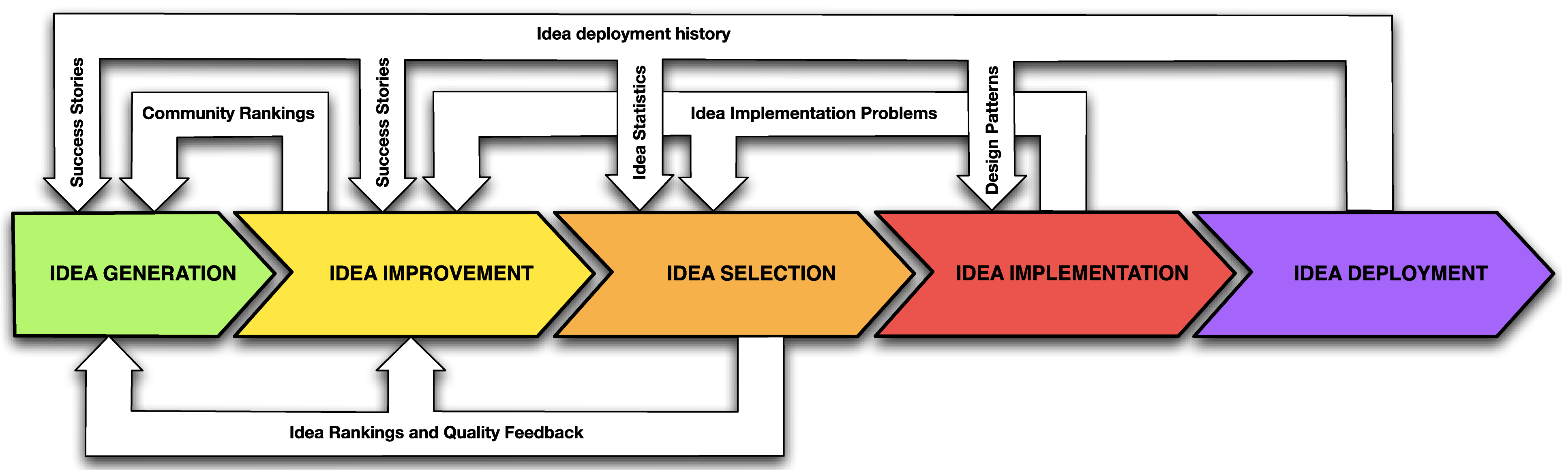

**Figure 3.** Idea life cycle dependencies.

**Idea Improvement**

The community rankings described earlier can be used for idea self- organization. This way the community's top rated ideas can be promoted and exposed stimulating creativity during the *Idea Generation* phase. In addition in Idea Management Systems based on game research (Baalsrud Hauge et al., 2008; Toubia, 2006) the community rankings can be shown to create game winning ideas.

**Idea Selection**

The idea ranking and assessment metadata can be easily reused in *Idea Generation* and *Idea Improvement* phases. The data can be passed to community moderators and users can be notified at generation time about some additional criteria for the ideas that the organization currently seeks. Also the metrics defined during assessment phase can be employed to provide hints in real time for idea usefulness (e.g. tag analysis- comparing user input with keywords for current idea campaign). Furthermore, the defined metrics and internal idea rankings can be used to order ideas so that the most valued ones are additionally promoted among users during the idea competition event in the *Idea Improvement* phase. Such practices help to show what is valuable for the company and give a better idea for the users on how to improve their own ideas.

**Idea Implementation**

During idea implementation the development team is given information provided by the inventor and has to relate it to the reality of the organization (e.g. technology process, organizational capabilities, available resources etc.). This way some potentially valuable and promising ideas are intersected with typical product or service development problems. This information can be also valuable to transfer to the *Idea Selection* phase for improving selection of ideas in the future (for instance as encountered problems and issues that reviewers should pay extra attention to).

In addition, the information can be used by community moderators during the *Idea Improvement* phase. The more the moderators are aware of desirable idea descriptions the better they can steer and direct the community to improve the current ideas. Moderators can point out and stimulate contributions from the crowd based on the feedback from implementation teams that were missing particular information or in large part found some data useless (or even making their work harder).

**Idea Deployment**

The idea deployment phase can potentially bring a lot of valuable data as feedback for every stage in the Idea Management cycle. In addition, it is not only important to reuse the data in real time as they come but also run statistics and detect patterns of successful and unsuccessful ideas.

For the *Idea Implementation* phase the outcomes of ideas such as product opinions or financial statistics like sales data or return of investment can help to identify problems in the implementation phase (for instance two equally promising ideas selected for implementation but due to different development team composition one got less successful; potential reason could be e.g. too big time to market, choosing bad technical solution, or even skipping some of the original idea information). In practice, this information can aid process improvement and making some strategic decisions for future improvement. However, it has to be noted that to apply such analysis the Idea Implementation process needs to be very well defined.

In the case of the *Idea Selection* phase, similar statistics as for Idea Implementation can aid greatly to choose the correct ideas and in identifying patterns for ideas that turn out to be bad in practice. Similarly, to analyse faults of the idea assessment process and improve it, it has to be very well defined and documented (e.g. the reason why a particular idea was chosen has to be clear and document).

In addition, properly prepared idea outcome data can be used as a motivator both in *Idea Generation* and *Idea Improvement* phases. The ideas that got implemented and furthermore had very good reception as services or products can be exposed as success stories. Such practices shall both encourage potential contributors to share their ideas and in addition deliver patterns that show how to describe ideas so that they become successful.

# Conclusions

In the article, we have introduced the topic of Idea Management Systems - one of the key software support tools associated with the area of modern innovation management. We presented a novel classification scheme for Idea Management Systems as well as the Idea Life Cycle concept. Furthermore, we have pointed out how the participative role of web communities and enterprise communities can inﬂuence the ﬂow of data in the entire life cycle and pointed out the ways in which proper idea management practices can close the cycle to interact with the communities. Nevertheless, it should be noted that for introductory purposes our aim was to describe the topic in a generic and accessible way. Therefore, the presented cycle does not fit every single system in detail on the dynamically growing idea management market nor does it cover every technique available.

In comparison to the state of the art in the area, rather than being a comprehensive view on the vendor landscape, we recommend this article as a framework for characterisation of the contemporary systems and a reference on modelling information ﬂows between enterprises and their related communities. We perceive and use ourselves the presented research and gathered knowledge as a basis for referring to particular elements of the Idea Management Systems and recognising areas in which techniques from other domains can be applied to harness community created innovation data.

In terms of future trends, in our opinion the development of idea management technologies will continue on all stages of the presented Idea Life Cycle. As the Web evolves and services direct towards mobility, the user front-ends of Idea Management Systems shall follow adapting to new ways of interaction with the communities in pursuit of extending the user base and increasing market penetration. On the other hand, the contemporary problems of informational chaos and data overﬂow in the communities will force to continue the development and improvement of back-end systems that facilitate the late stages of the Idea Life Cycle.

Furthermore, we notice that it is an important question for Idea Management Systems whether should they or should not invade the space of other dedicated management applications such as project management, or product life cycle management. The trend among contemporary applications seems to evolve towards complex solutions delivered by one vendor that span the entire life-cycle presented here. The support for the first three life cycle stages is standard among most of the applications on the market whereas many systems already start to cover the idea implementation phase as CEOs often mention the need for idea management as one complete and repeatable process (Turrell, 2008).

In our opinion, while extending the scope of idea management is important, the research and improvement of the already covered phases should not be neglected. There is still a lot to be achieved in the idea generation, improvement and selection stages. Surely, among others, the aforementioned problems of data volume and redundancy should be addressed and worked on.

Finally, regardless of the direction that shall be taken, the results of market analysis (Gartner, 2010) allow to conclude that the improving establishment of Idea Management Systems on the market is a testament to the increasing role of web communities in innovation.

# References

AcceptIdeas (2009), 'Accept Ideas homepage', http://www.acceptsoftware.com/

Andrew, J. P., Haanæs, K., Michael, D. C., Sirkin, H. L. & Taylor, A. (2009*a*),

'Innovation 2009. Making Hard Decision in the Downturn ', Technical report, Boston Consulting Group

Andrew, J. P., Haanæs, K., Michael, D. C., Sirkin, H. L. & Taylor, A. (2009*b*), 'Measuring Innovation 2009. The Need for Action.', *A BCG Senior Management Survey*, Technical report, The Boston Consulting Group

Andrew, J. P., Stover DeRocco, E. & Taylor, A. (2009*c*), 'The Innovation Imperative in Manufacturing'. *How the United States Can Restore Its Edge*, Technical report, Boston Consulting Group

Baalsrud Hauge, J., Duin, H. & Thoben, K. D. (2008), 'Applying Serious Games for Supporting Idea Generation in Collborative Innovation Processes. ', *In Proceedings of the 14th International Conference on Concurrent Enterprising, ICE2008*, Lisbon, Portugal

Baumgartner, J. (2004), 'Big and Little Innovation, Report 103', http://www.jpb.com/report103/archive.php?issue/_no=20040427

Bothos, E., Apostolou, D. & Mentzas, G. (2008), 'IDEM: A Prediction Market for Idea Management. Designing E-Business Systems. Markets, Services, and Networks', *In 7th Workshop on E-Business, WeB 2008*, Paris, France.

Cabena, P., Hadjinian, P., Stadler, R., Verhees, J. & Zanasi, A. (1997), *Discovering Data Mining: From Concept to Implementation*, Prentice Hall.

CVS (2009), 'Concurrent Versions System (CVS) project homepage', http://www.nongnu.org/cvs/

Dell (2009), 'Dell IdeaStorm homepage', http://www.ideastorm.com/

Gartner (2010), 'Gartner's 2010 Hype Cycle Special Report Evaluates Maturity of 1,800 Technologies', http://www.gartner.com/it/page.jsp?id=1447613

Hu, M. & Liu, B. (2004), 'Mining and Summarizing Customer Reviews. ', *In Proceedings of ACM SIGKDD International Conference on Knowledge Discovery and Data Mining (KDD'04),* Seattle, Washington, USA, pp. 168-177

IBank (2009), 'Ingenuity Bank homepage'. http://www.ingenuitybank.com/

IdeaCentral (2009), 'Imaginatik IdeaCentral product page', http://www.imaginatik.com/webdoc/_prod/_idc/_description

Idearium (2009), 'Idearium project page', http://www.laboranova.com/tools/idearium

IdeaScale (2009), 'IdeaScale product page', http://ideascale.com/

Jouret, G. (2009), 'Inside Cisco's Search for the Next Big Idea.', *Harvard Business Review*

Kanerva, M. & Hollanders, H. (2009), 'The Impact of the Economic Crisis on Innovation. Analysis based on the Innobarometer 2009 survey. ', Technical report, PRO INNO Europe

Liu, B. (2008), 'Opinion Mining and Summarization, ', *In World Wide Web Conference 2008 (WWW2008),* Beijing, China

Nesco (2009), 'Nesco Idea Exchange product page', http://www.nosco.dk/product.html

Newsfutures (2009), 'Newsfutures Idea Pageant product page', http://us.newsfutures.com/home/ideaPageant.html

Pang, B., Lee, L. & Vaithyanathan, S. (2002), 'Thumbs up? Sentiment Classification using Machine Learning Techniques. ', *In Proceedings of the 2002 Conference on Empirical Methods in Natural Language Processing (EMNLP),* Philadelphia, PA, USA, pp. 79-86

Pipeline (2009), 'BrightIdea Pipline product page', http://www.brightidea.com/pipeline.bix